Technical Design Document

For ReOffer Campaign January 2013

**Revisions**

|  |  |  |  |
| --- | --- | --- | --- |
| Rev. | Date | Author | Description |
| 1.0 | 13/12/2012 | Ofer Sasson | Initial Draft |
| 1.1 | 13/12/2012 | Eyal Zoref | Design Review + fixes |
|  |  |  |  |

1 Introduction 3

2 Re-Offer campaign for users with toolbar installed 3

3 Re-Offer campaign for users without toolbar installed 3

4 "Remind me later" 4

5 Toolbar Instillation 5

6 Measurements 5

7 Flowchart Diagram 6

# Introduction

This document describes the campaign on January offering the toolbar, DSP, homepage and new tab to all AV users and 3rd party users.

We will launch the campaign in two different situations:

1. Launched from the updater, for users with a toolbar installed (As done in previous toolbar campaigns).
2. Launched from the AV, for users without a toolbar installed.

Two different ".exe" files will be compiled, one for each of the situations described above. The binaries will be based on the same code, but with different configurations at the bundled ROC.ini file.

The campaign IDs:

* AVG_Search_January_Campaign (AV Users w/o toolbar)
* AVG_Toolbar_January_Campaign (toolbar users)

## 2 Re-Offer campaign for users with toolbar installed

The campaign will run the same as the previous campaigns (Launched from the updater). For more information please see "ReOffer Campaign 11.1.0.7".

Two new changes will be added to this campaign:

* The campaign will be offered only for users who installed the toolbar before Dec 9. Server side.
* The user can choose to remind him later. For more information, please review "Remind me later" section.

## 3 Re-Offer campaign for users without toolbar installed

In this scenario the user will not have the toolbar installed (Which means Updater, vprot and ScriptHelper do not exist on the user's machine), so all the code will be included in the same campaign ".exe" file.

Because the ScriptHelper is not installed on the user's machine, the following functions have been added to the HTMLDialog COM object:

* GetDefaultBrowser([out]BSTR *bsDefBrowser)
* IsHostBrowser([in]BSTR bsfBrowser,[out]BOOL *bVal)
* IsBrowserOpen ([in]BSTR bstrBrowser, [out,retval]VARIANT_BOOL* bRetVal)
* InstallToolbar()
* SetRemindMeLater([in]ULONG ulInDays, [in]ULONG ulInHours, [in]ULONG ulInMinutes)
* SetHomepage ([out, retval] BSTR* bRetVal)
* SetDefualtSearchProviderByBrowser([in]BSTR bstrBrowser, [in]VARIANT_BOOL bCloseBrowser, [out,retval]VARIANT_BOOL* bRetVal)
* CloseBrowser ([in]BSTR bstrBrowser, [out,retval]VARIANT_BOOL* bRetVal)
* SetPartner([in]BSTR bstrPartner)

Because the toolbar's registry keys do not exist, the campaign needs to generate part of the data by itself (e.g.: Machine ID, Client ID, Product ID and the user's language).

The user's language will be taken from the AV itself.

For AV users, the campaign will offer a toolbar installation (In addition to all the other offers, for the users with a toolbar installed). For more information please see the "Toolbar Installation" section.

**Steps for installation of the ROC by the AV**:

1. The AV updater will get an update with the bundled ROC.
2. The AV updater will run the ROC, which will run in the SYSTEM account with flag /UPDATE
3. The ROC.exe file will be copied to "C:\Program Files\AVG Safe Guard\January Campaign".
4. The Installers files will be copied to "C:\Program Files\AVG Safe Guard\January Campaign ".
5. The SYSTEM account's ROC will create a new ROC process that runs as User with flag /PROMP. The process will run from the "Program Files" folder.
6. The new ROC process will show the ROC window.
   1. If the user chose to install the toolbar – the installer will be executed, as described in "Toolbar Installation" section.
   2. If the user chose to only set SAPs – the installer will be executed without /INSTALL flag
   3. If the user chose to remind him later – A new job will be added to the "Windows Jobs Scheduler", as described in "remind me later" section.
7. When the user's ROC process will finish its job the SYSTEM account ROC will delete the program files folder.

## 4 "Remind me later"

A new feature is the "Remind me later" button. For this feature, the "Windows Tasks Scheduler" will be used.

The user can choose between 3 options: 1 hour, 1 day and 1 week. After the user clicks on the OK button, the server web page will call an HTMLDialog COM object function, which create a new task and add it to the "Windows Task Scheduler". In any case, after the user chooses to accept or decline the campaign, there should be no ROC tasks at the "Task scheduler".

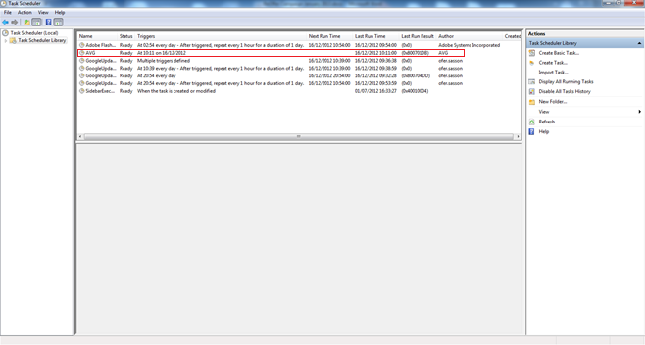

## 5 Toolbar Installation

This section is relevant only for AV users without the toolbar. For those users the ROC will offer the safeguard toolbar.

The ROC.exe is bundled side by side with the safeguard installer in a self-extractable file. When the AV updater receives the ROC package, we can be sure that the installer is in the same folder as the ROC file (So the ROC can know the installer's path). If the user chooses to install the toolbar, the ROC will execute the install process with admin privileges.

Because the AV is installed on the user's machine, the toolbar installation will not add registry keys that add the toolbar to the Control panel's "Add/Remove program".

## 6 Measurements

Server side.

# 7 Flowchart Diagram







